Screenshot for Capstone Project :

**Please run npm start.**

Will start both the Backend and Front-end Application by using the concurrently Module.

**Home Page:**

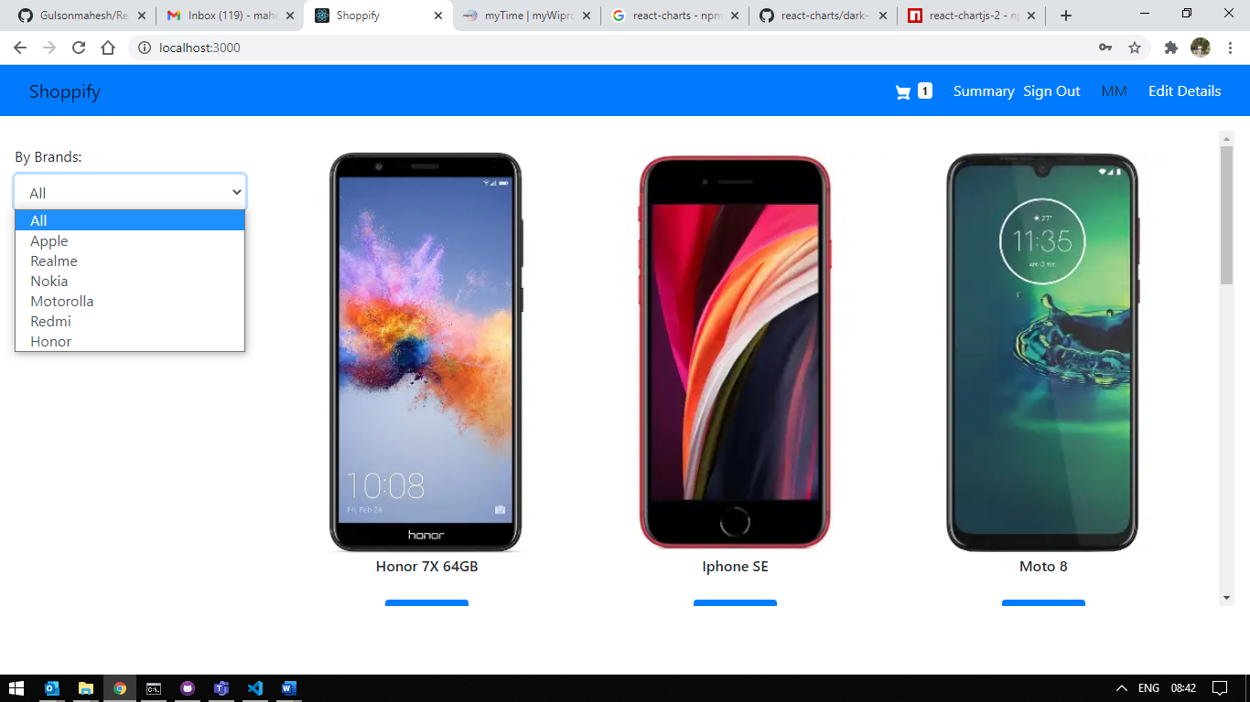

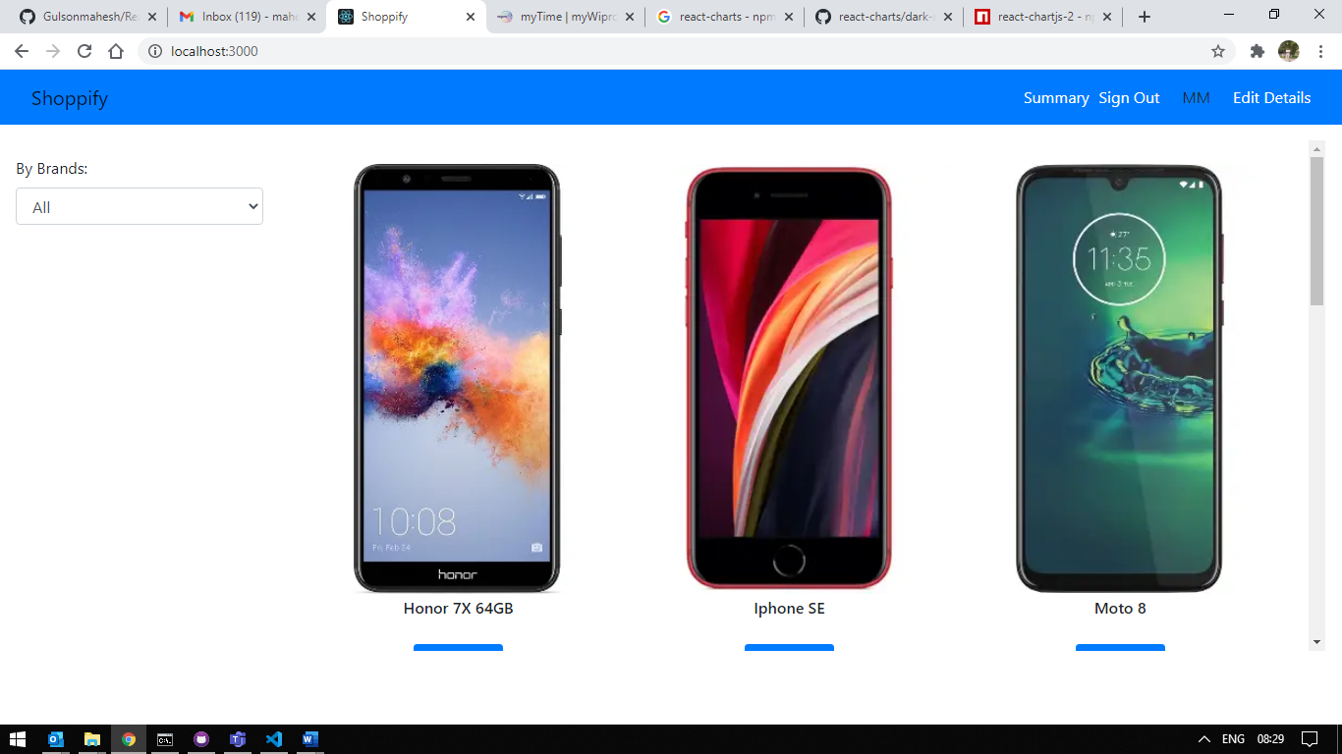

**Filterer Items:**

Here I am filtered only Apple product Modals

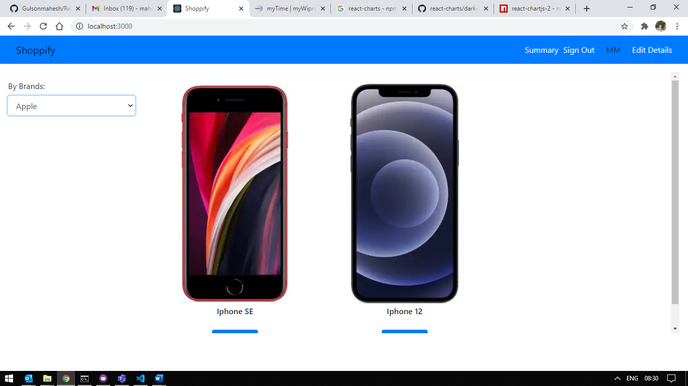

**No Items:**

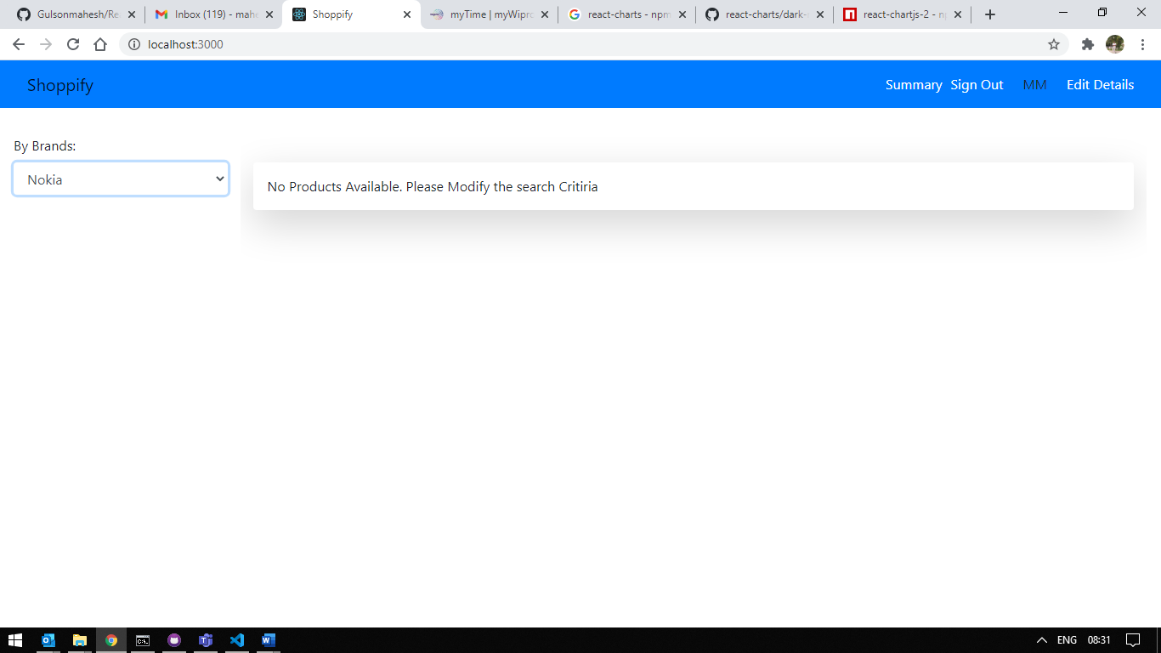

**Product Details:**

On clicking the product image it will redirect to the product details Pages

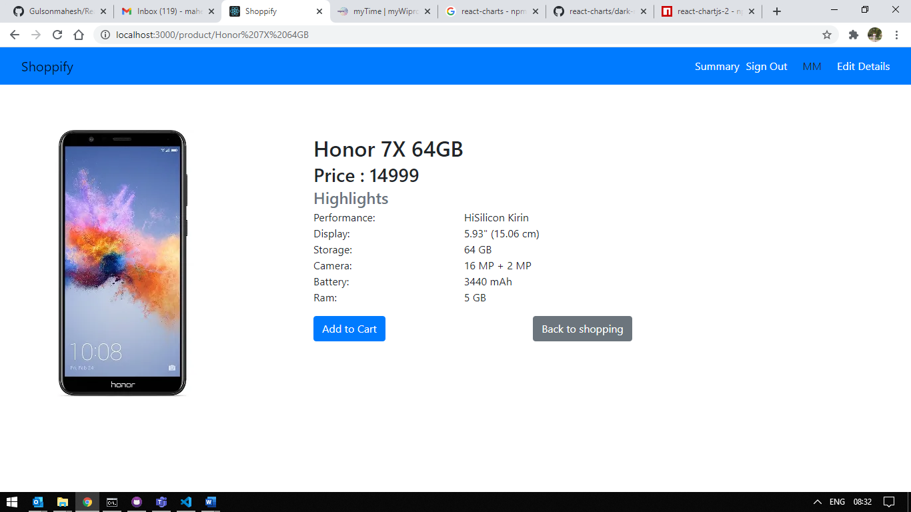

On clicking add to cart will added the product and cart icon will appear, if products are there in the cart back to cart button will appear else it wont appear.

On clicking back to shopping will take to the Home page of shoppify

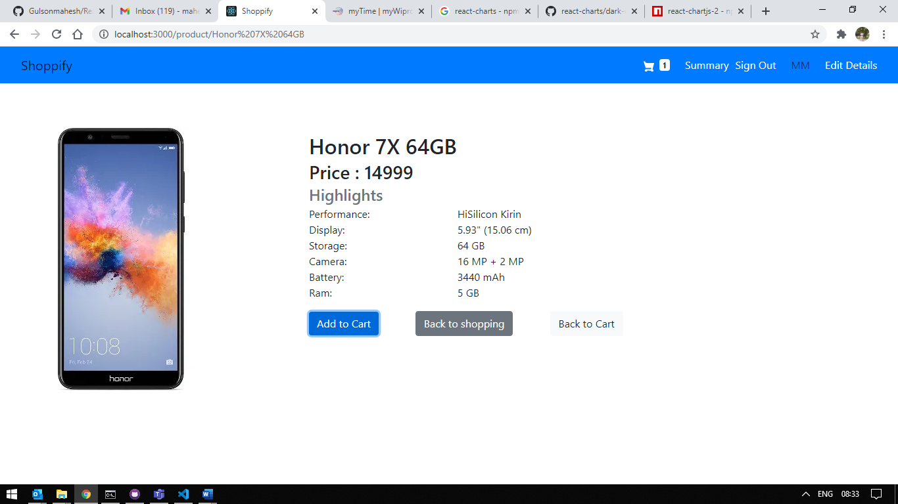

**Summery Page:**

If you have an admin you can see the options to CRUD options on the product else you won’t see the options only the product inventory you will see. Here also you can see the go to the product details by clicking the name of the product.

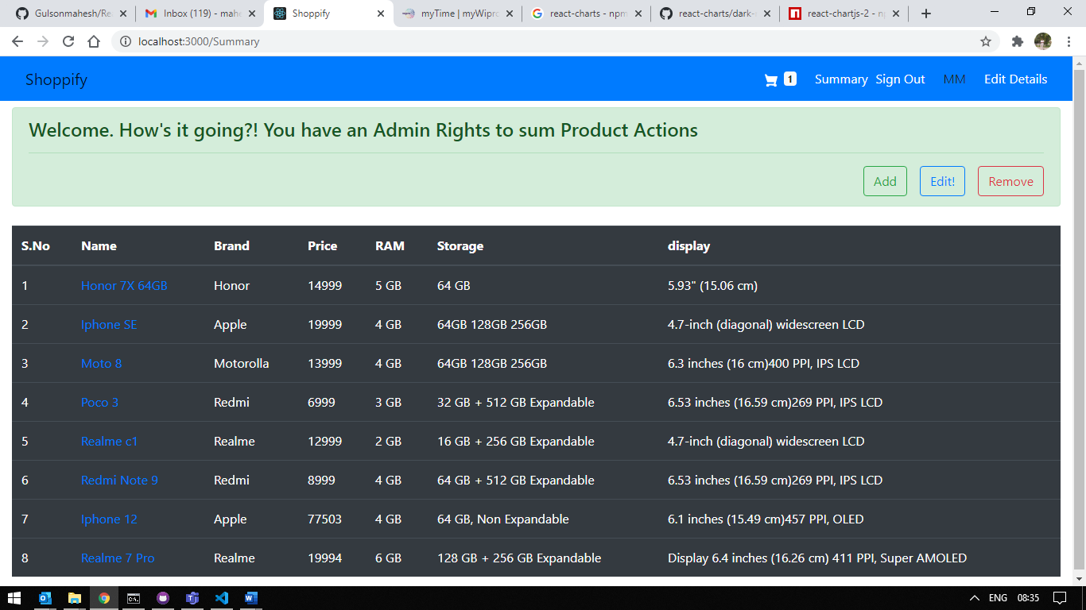

**Edit Product:**

By clicking of edit and enter the id of the product will give the product edit form ( Admin Rights Needed )

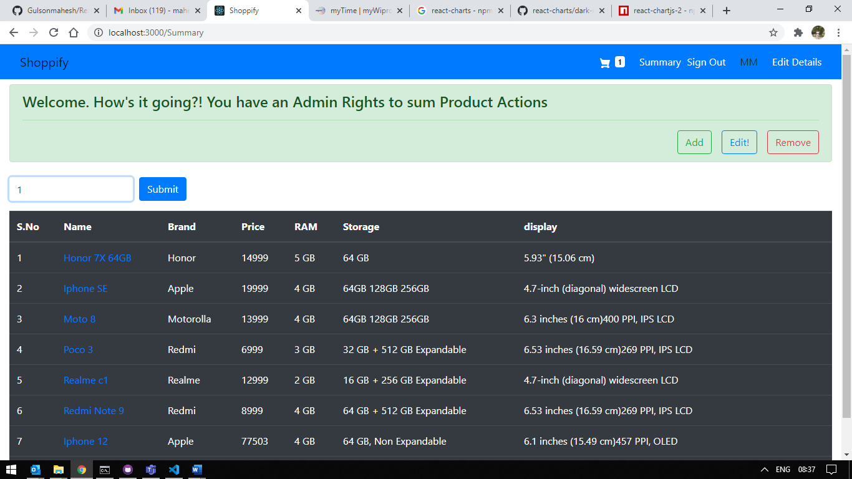

Will take you to the Product Edit Page.

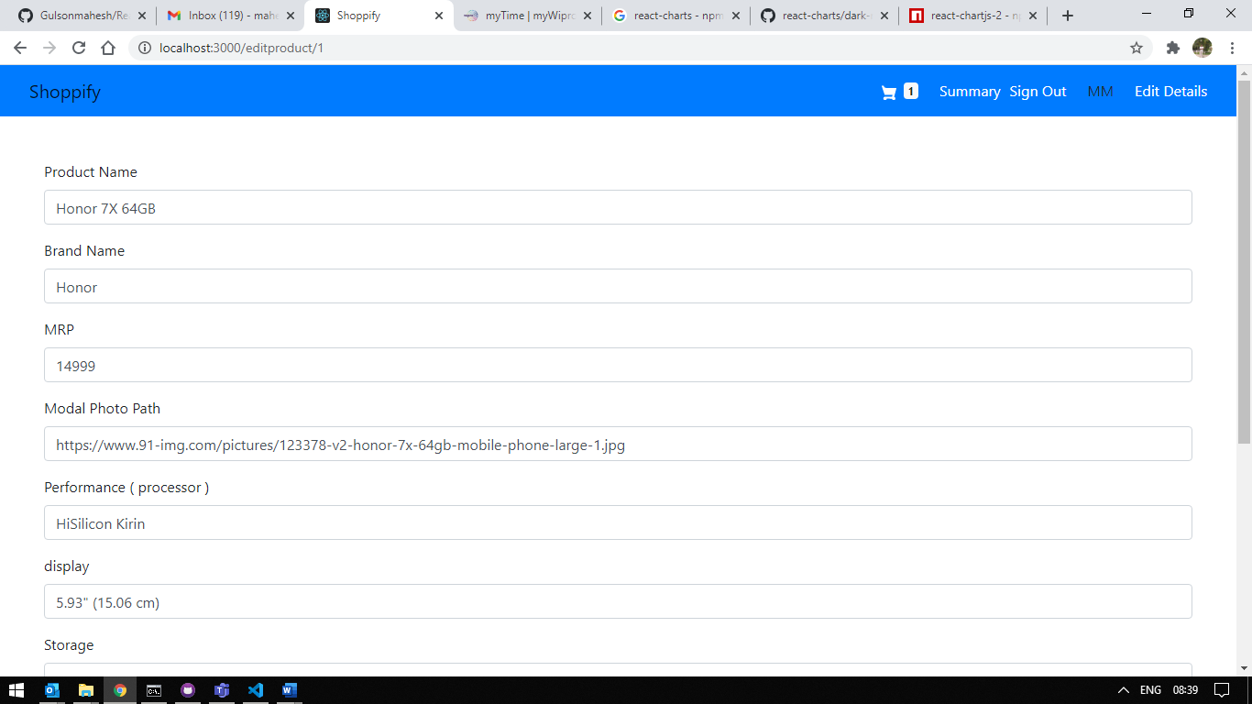

**Add Product:**

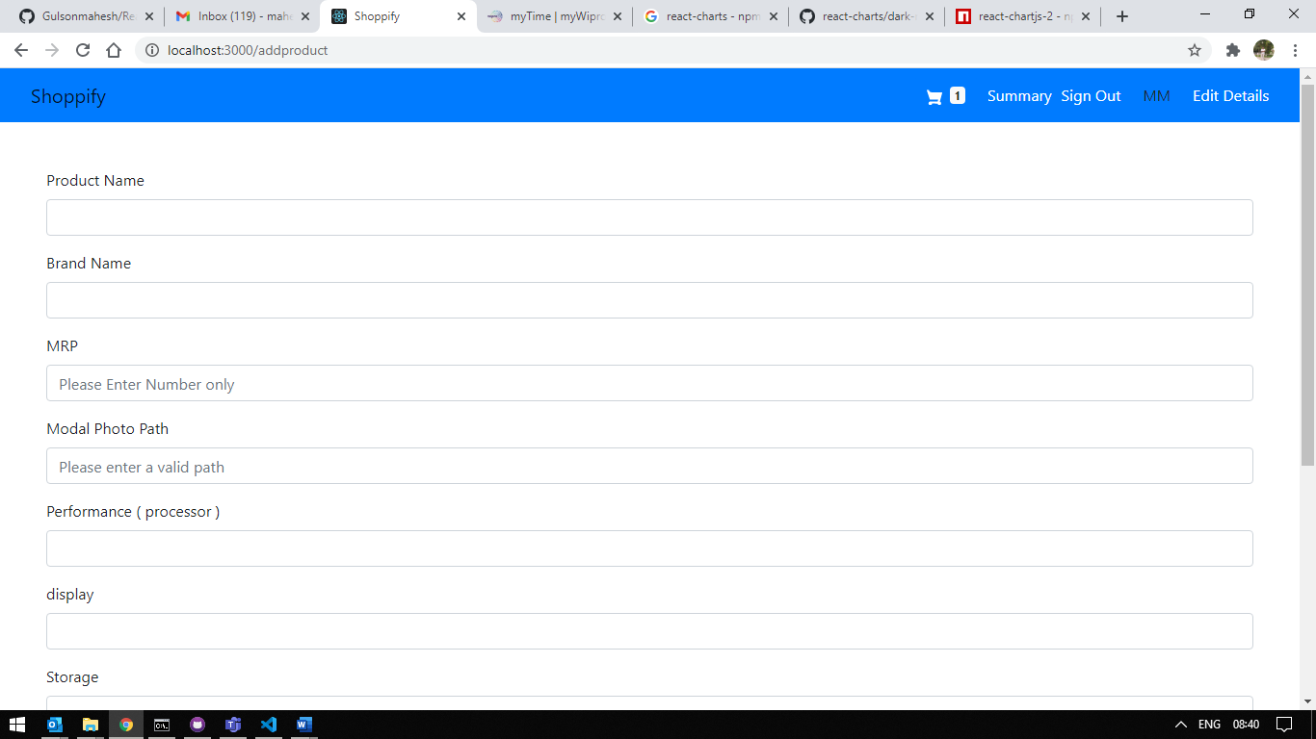

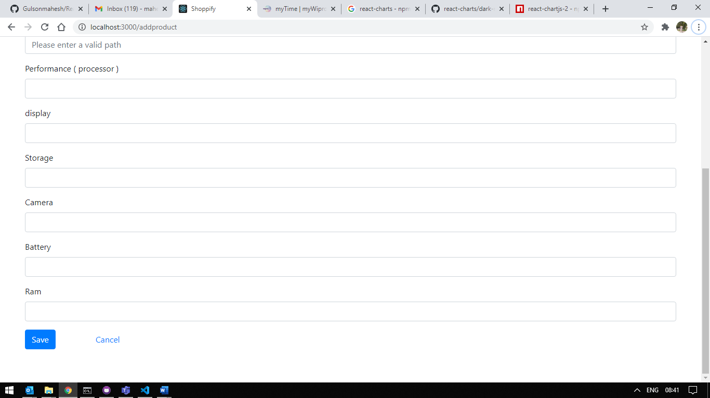

**Cart:**

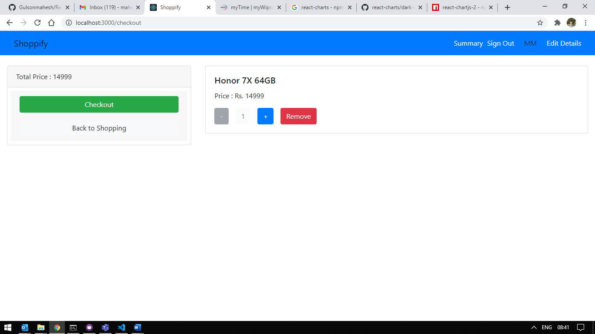

**User Edit:**

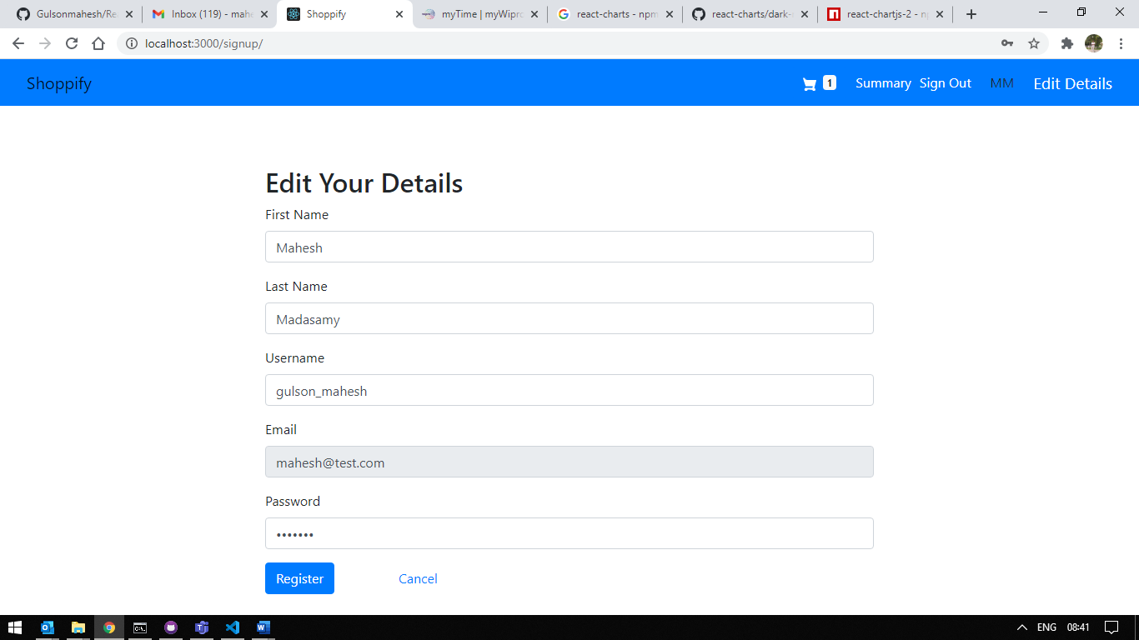

**Login Screen:**

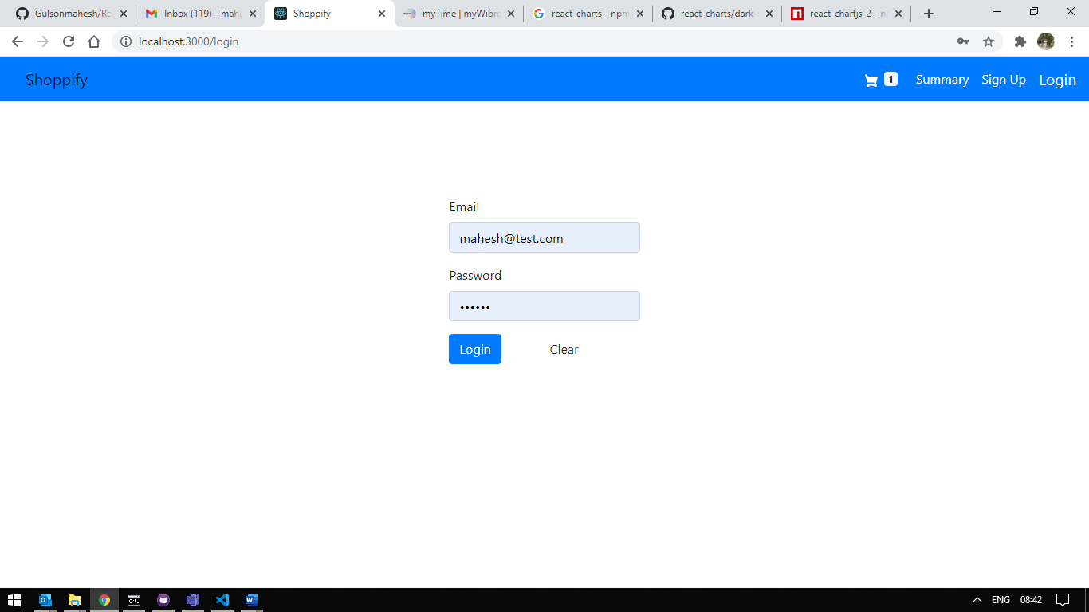

**Login Success:**

